1. | a) | Define the term “Data Mining” and give an example where human always use data mining techniques.
 | b) | What are the difference between classification and clustering?
 | c) | In the real life, where do you use association rule?

2. | a) | If you have number data i.e. income, you have to standardize them. Write the process of it.
 | b) | For ordinal and nominal data, how do you calculate dissimilarity for a single attribute?
 | c) | In what aspect, you may like decision tree classification?

3. | a) | How a tree-based classification works? What are the advantages of tree-based classification?
 | b) | Suppose you have two variables (Gender and Marital status) to select one in constructing a tree.  Which variable you should select? Use Gini coefficient or entropy to give your answer.
    Gender | Marital | Class
    M | M | Good
    M | U | Bad
    M | M | Good
    F | U | Bad
    F | U | Bad
    Gender | Marital | Class
    M | U | Good
    M | U | Bad
    F | M | Good
    M | M | Good
    F | U | Bad
 | c) | Define the terms: True positive and False Negative and F-measure

4. | a) | When do we use learning curve and ROC curve?
 | b) | Explain the Ensemble Method of classification.
 | c) | What is OLAP? Why do researcher use Slicing and Dicing in data analysis?

5. | a) | What are the steps of KNN classification?
 | b) | Why do the most researchers prefer SVM classification?
 | c) | If you have a nominal attribute which has 3 categories and for binary tree classification you have to merge any two categories. Which two will you merge?

6. | a) | Define hierarchical clustering and give an example of this clustering where it is the most useful technique.
 | b) | What are the different types of clustering?
 | c) | Write some limitations of k-means clustering. How can you overcome these limitations?

7. | a) | What is the basic principal of DBSCAN clustering? Write the usefulness of this clustering.
 | b) | Explain with a pictorial example of Core Point, Noise Point and Border Point.
 | c) | The distance of k-th neighbor of data points are almost equal” – explain this comment.

1. | a) | Define Data Mining? There are two types of Data mining techniques: supervised and nonsupervised classification in data mining- give example of these two.
 | b) | What are the difference between classification and clustering in data mining?
 | c) | Why do we use test data in data mining?

2. | a) | Define the terms: Euclidian distance, PCA, and slicing
 | b) | When there is missing data, what are the ways to handle this missing data?
 | c) | How do we sometime use bagging in data mining?

3. | a) | Why and when do we use Gini coefficient or entropy?
 | b) | 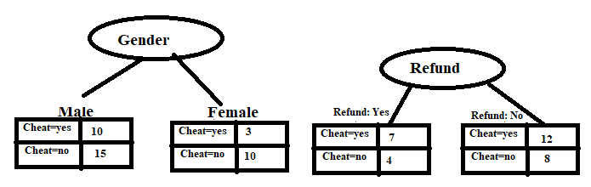  Which variable you should select? Use Gini coefficient or entropy to give your answer.
 | c) | Give a example of binarization.

4. | a) | Define the term roll-up and roll-down. Why EDA is necessary before data mining?
 | b) | What do you mean by slicing and dicing? Why and when do we use slicing and dicing?
 | c) | Consider a 2-class problem (cancer yes, cancer no) where actual number of ‘cancer yes’ was 6990 and number of ‘cancer no’ was 3010. Using the diagnostic machine it was found number of ‘cancer yes’ 5710 and number of ‘cancer no’ was 4290. Calculate recall, precision and F-measures and comment on the results.

5. | a) | What are the steps of KNN classification?
 | b) | List different types of classification techniques.
 | c) | “KNN Classification has many drawbacks” – explain what those drawbacks are?

6. | a) | What do you mean by clustering? What are the different types of clusters?
 | b) | What are the main strengths of hierarchical clustering?
 | c) | Write the algorithm of hierarchical clustering in your own words sequentially.

7. | a) | What do you mean by centroid in k-means clustering?
 | b) | How do we estimate epsilon (EPS) and minimum points (MinPoints) in Density Based Clustering ?
 | c) | Write two limitations of k-means clustering. How can we minimize these limitations?

